Water safety advice.

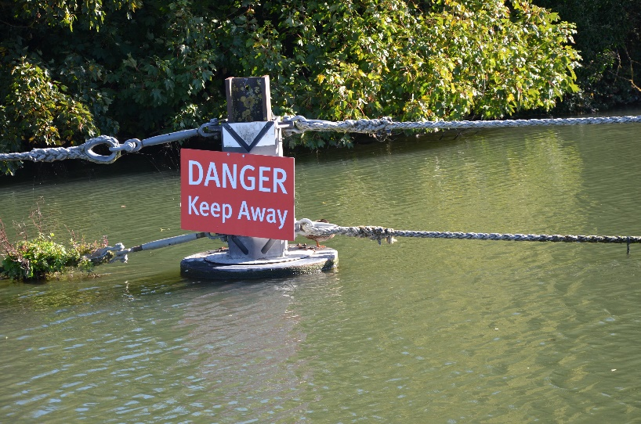

Spending time near water can be fun, especially in warm weather, but open water can be dangerous even if you are a strong swimmer. Rivers, lakes, canals, quarries and reservoirs can be much colder than they look, with hidden hazards and strong currents.

- Do not jump, dive or swim in open water unless it is a supervised, designated place.
- Never go near water alone - stay with friends and make sure someone knows where you are.
- Be aware that cold water shock can affect anyone, even strong swimmers, and can make it hard to breathe or move.
- Rivers, canals and lakes may have hidden dangers under the surface such as rocks, rubbish, weeds, fishing line or sudden drops.
- Do not take risks to impress others, including dares, bridge jumps or entering the water for social media content.
- If you fall in, try to stay calm, float on your back, keep your airway clear and control your breathing.
- If you see someone in trouble, call 999 or 112, shout for help, and throw something that floats. Do not go in after them.
- If possible, choose supervised swimming venues or pools instead of unsupervised open water.
Remember: Enjoy the good weather, look out for your mates, and stay safe around water.

